FOR OFFICE USE ONLY. File Ref: Date of Receipt:
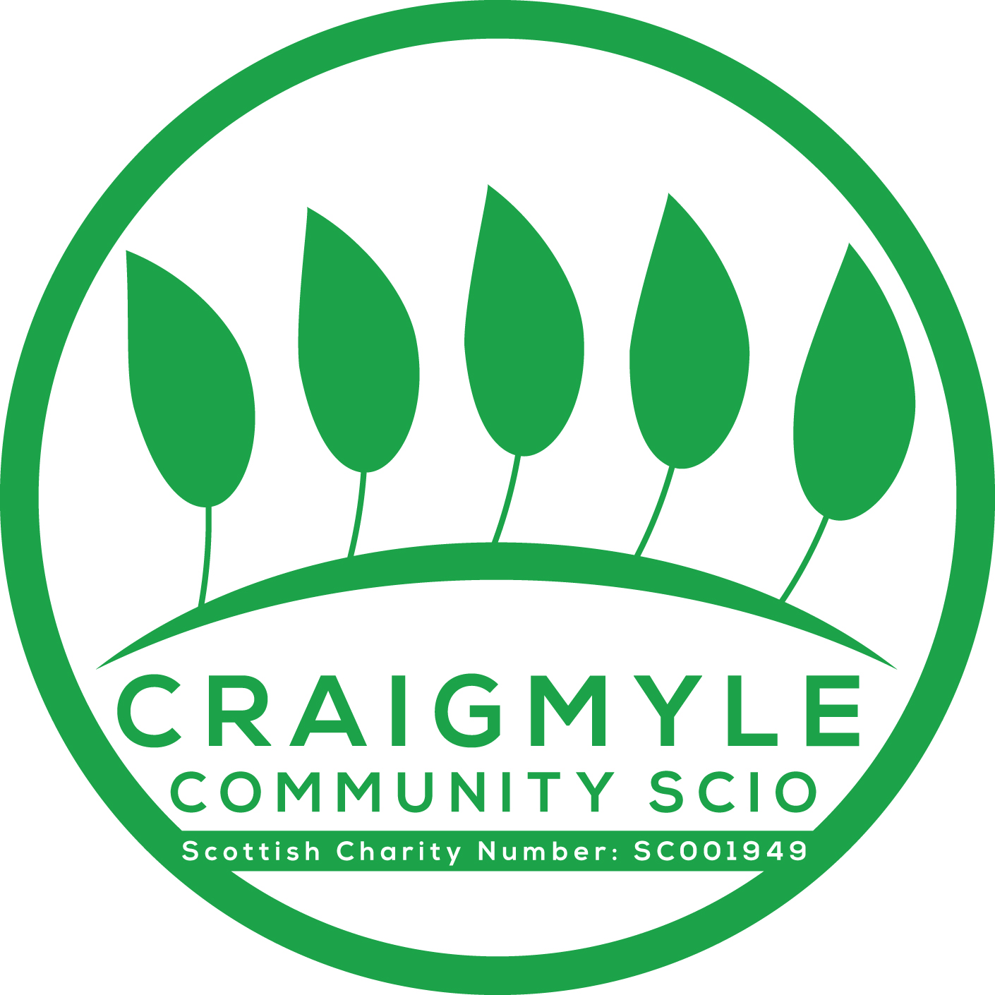

Craigmyle Community SCIO
Application for financial support for groups and organisations

Organisation Name:

What is the main objective of your group or organisation? Tell us what it does and why.

Contact details:
First Name: | Surname:
Contact address:
Area: | Postcode:
 Telephone (daytime):
 Email (if you have one):

Activity:
Brief description of proposed project, describing what you want to achieve (Please be specific about how the money will be used):

When are you planning for your project or activity to take place (please give a start date and end date)

Where will your project take place?

Support:
How much is your project going to cost?
Your contribution: £
Other grants received: £
Request from Craigmyle Community SCIO: £
Total: £

Benefit:
Please outline how the participants of your project have been involved in the planning:

How many disabled people will directly benefit from your project?

How will you measure the success of your project?

Eligibility Checklist:
This checklist will allow us to quickly confirm that your project meets the first eligibility check we carry out on receipt of your application.

Please tick () all that apply:
 | Yes | No
Will your project benefit people with a learning disability?
Will your project benefit people with a physical or sensory impairment?
Will your project benefit people with mental health problems?
Are you prepared to feedback on the use of any award given
Have you signed and dated the application form

Awards to successful applicants will be made by bank transfer. Bank account details will be requested to enable the transfer.
NAME (please print):

Signature:
The above information is correct to the best of my knowledge:

Signature: | Date
NAME (please print):

You must attach a statement of support to your application from someone who knows your group or organisation. Please return your completed form to:
Iain Fraser, 44 East Park Road, Kintore, Aberdeenshire AB51 0FE
Email: iainkfraser@btinternet.com

